**Analysis Report**

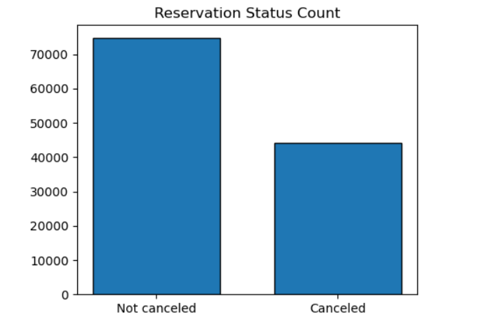

Above graph shows the share of reservation that are cancelled and those that are not. It is very obvious that there is still a considerable number of reservations that have not been cancelled. There are still 37% of clients who cancelled their reservation, which has significantly impact on hotel reservations.

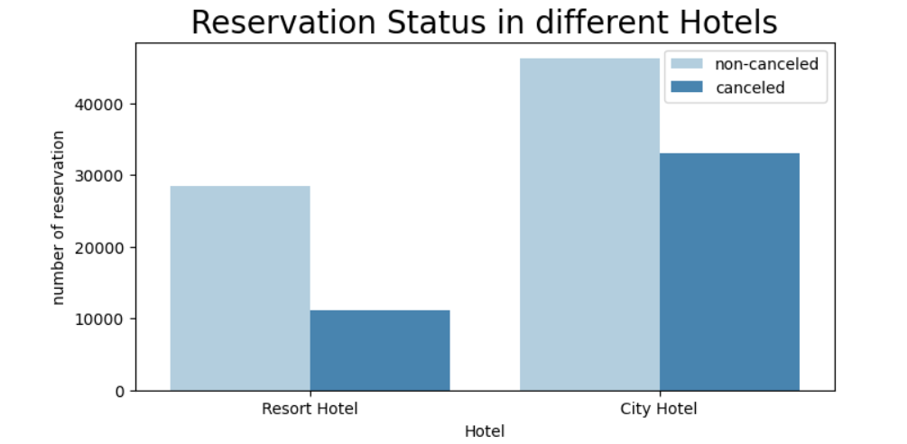

In comparison to resort hotels, city hotels have more bookings. It’s possible that the resort hotels are more expensive than hotels located in the city.

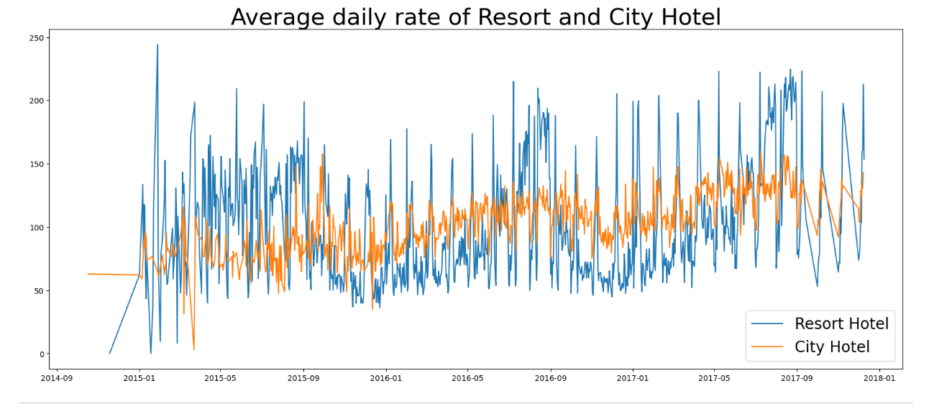

The line graph above shows that, on certain days, the average daily rate of the city hotel is less than that of a resort hotel. We can also observe that the rates for both city hotel and resort may rise on weekends and holidays.

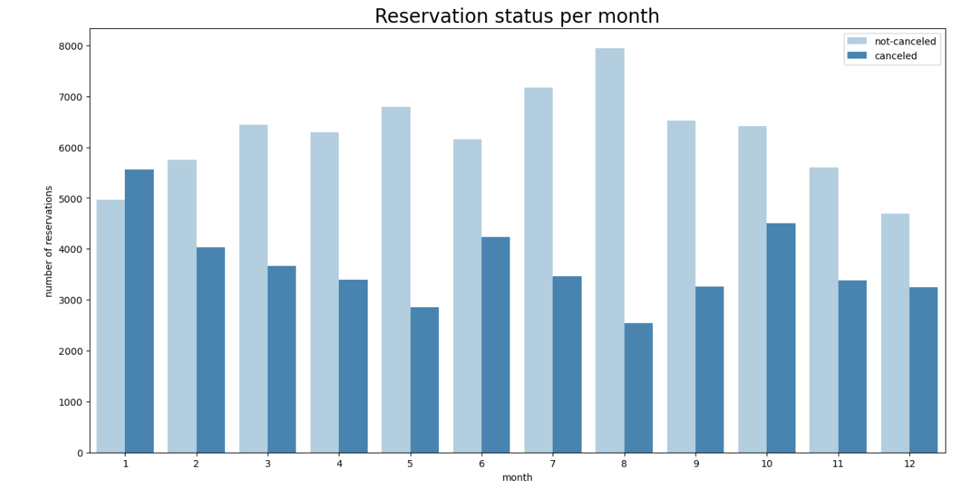

We have developed the above graph to analyse the reservation pattern throughout the months of the years. It is clearly visible, the highest reservations made and the least cancellation is in the month of August whereas, the highest cancellation is done in the month of January.

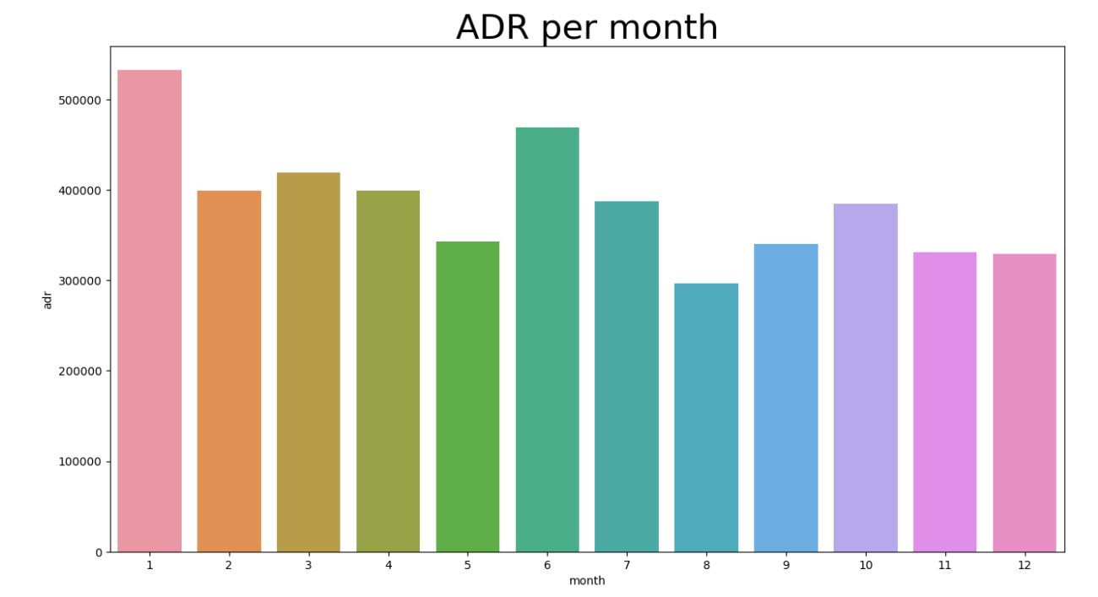

This graph demonstrates that the prices are highest in the month of January. Hence, we can conclude that the cancellation is high when prices are high and reservation is highest when the prices are the lowest. Therefore, the cost of accommodation is solely responsible for the cancellation.

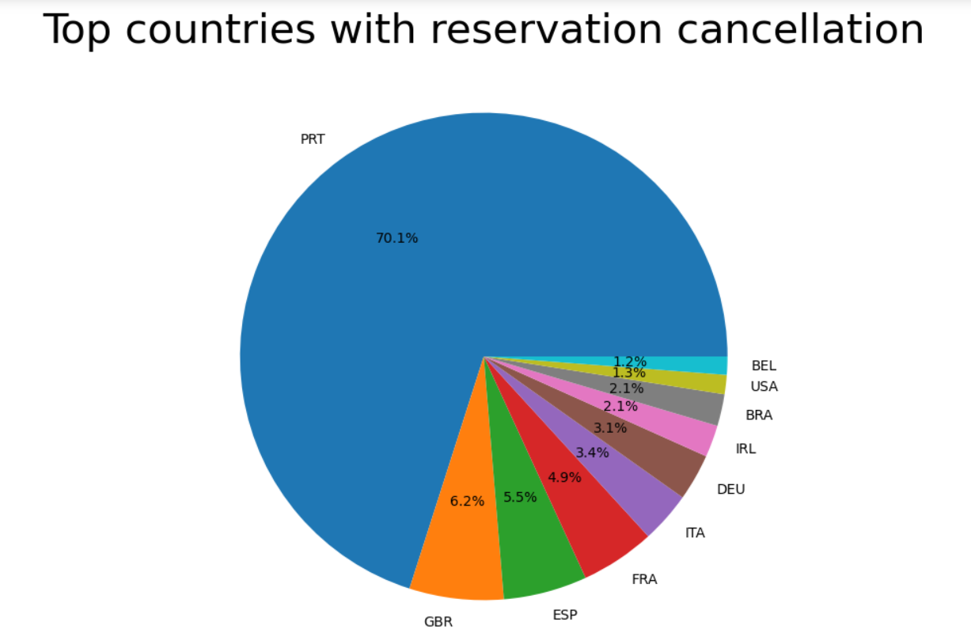

Portuguese are the highest amongst the people who are responsible for the cancellation. It clearly indicates that the hotels are not able to cater the Portuguese customers.

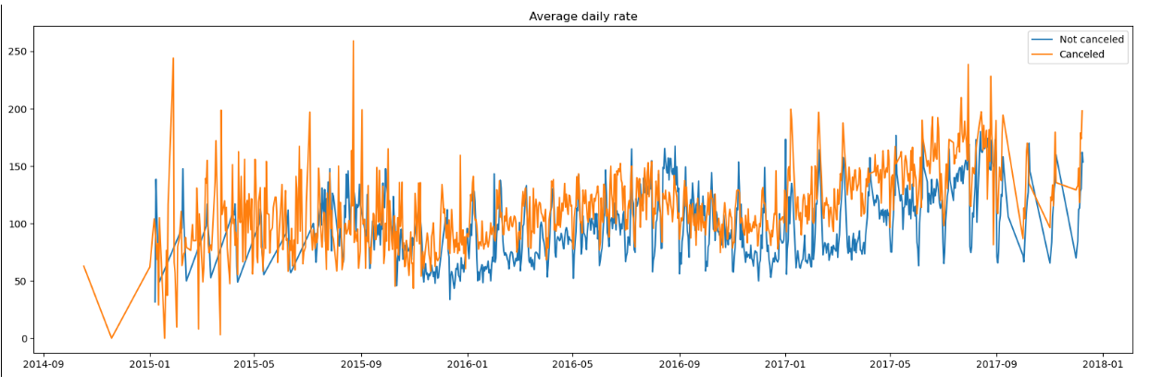

Above graphs give us the statistical data which clearly shows that the cancellation is higher when the rates of accommodation is higher. All the analysis above gives solid evidence that the cost of accommodation directly affects the cancellation.

Suggestions:

1. Cancellation is increased when the prices are increased. In order to prevent this, hotel can come up with pricing strategies. They can also provide discounts and offers to attract the customers
2. As the ratio of the cancellation to reservation of the city hotel is higher than that of resort hotels, city hotel should adopt the strategies to curb the cancellations.
3. In the month of January, hotel can start various campaigns and adopt unique marketing strategies to attract the customers. This month is important for hotel as it comes with a lot of holidays
4. As the cancellation is highest amongst the Portuguese customer as compared to other nationalities, hotel should focus on strategies to cater Portuguese customers